Online learning protocols for Learners.
5 key messages
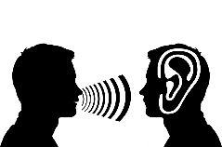
Check and set up your device before starting your online learning. Ensure you are in a quiet space and will not be disturbed, especially if you are at home.
Dress appropriately….you do not need to wear your work uniform on the online session, but you do need to dress appropriately – no pyjamas please!
Be on time. Plan and prepare yourself to ensure you can start the session on time.
You are not allowed to record or take pictures of the session.
Listen to others while they are speaking. Mute your device when asked too and use the hands up function if you need to ask a question.

Asset expectations for learners.
Be online and on time for my Video Conference sessions
Submit all learning tasks by the date planned
Stay in regular communication with your learning facilitator.
Keep online chat focused to the session only
Keep mobile phone off whilst attending any online session
Contact learning facilitator immediately if you experience any technical issues
Make sure the equipment you are using is fully charged
Be on time for your sessions and let your learning facilitator in advance if you need to rearrange
Have a pen and paper with you for each session in case you need to take notes
Advise your learning facilitator if you are struggling with any assignments or tasks set for you.

